Activity 23

NAME : Rose Mystica. J COURSE : Mobile Computing
Reg No : 192421410 COURSE CODE: ITA0302

23. Develop a user interface prototype in Figma showcasing security measures for a mobile app. Emphasize the intuitive design for user personalization.

Aim:
Developing a user interface prototype in Figma showcasing security measures for a mobile app.

Procedure:

- Define Presentation Structure
- Create a Figma Project
- Design Visual Elements
- Make it Interactive
- Add Annotations and Explanations
- Incorporate Multimedia
- Storyboard Animation
- Test the Prototype
- Collaborate and Gather Feedback
- Finalize and Share

Design:

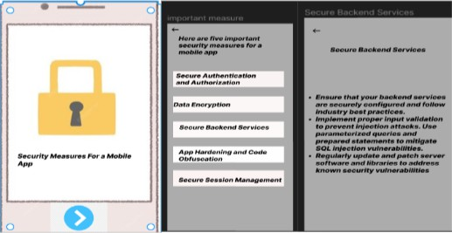

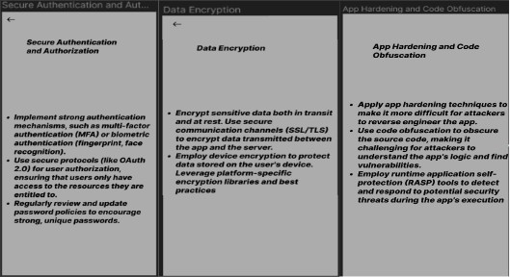

Prototype:

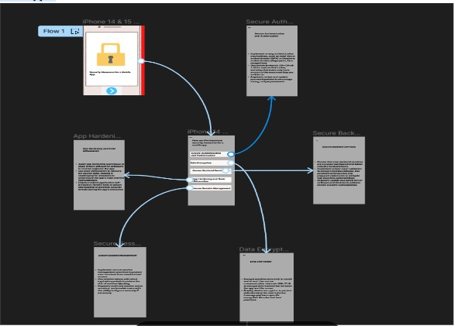

Result:
Hence an user interface prototype in Figma showcasing security measures for a mobile app have been created successfully

